# Prob1:

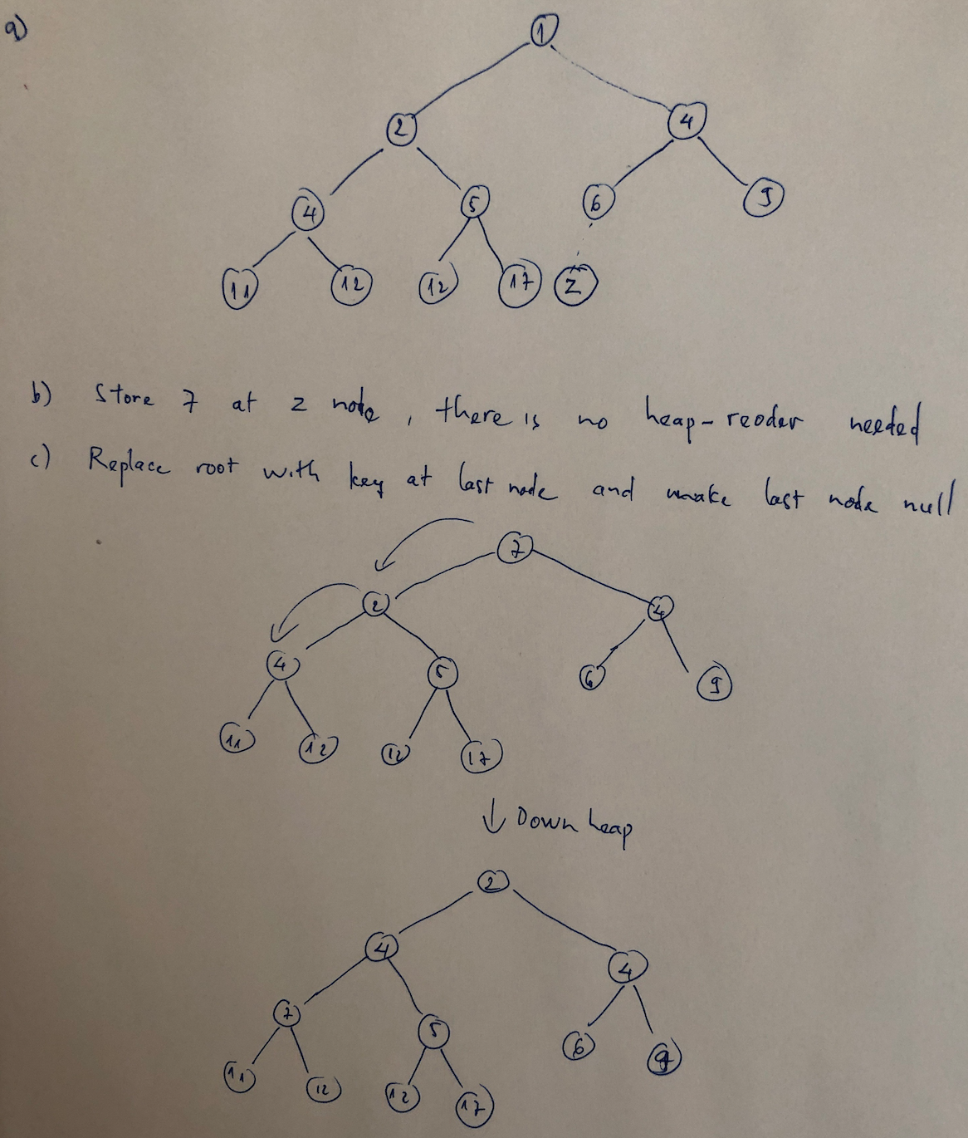

# Prob2:

# 

# Prob3:

